A2623-US-Cheyenne-Sandhill Massacre Drum-Thunderbird Parfleche-Ledger Type Drawing on Bison Rawhide-Cane Frame-December 1864

 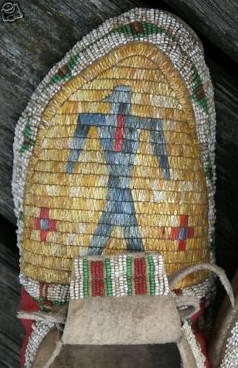

Fig. 1. Cheyenne War Drum Parfleche design of a *nemevota* or Thunderbird used as a tympanum for the Sand Creek Massacre Drum, December 1864.

Fig. 2. This beaded design of a *nemevota* or Thunderbird on a Cheyenne moccasin dates to the same general period as the Sand Creek Massacre Drum. After https://i.pinimg.com/originals/ac/9d/26/ac9d2679883e6bd0cc2d18ee8ea07807.jpg

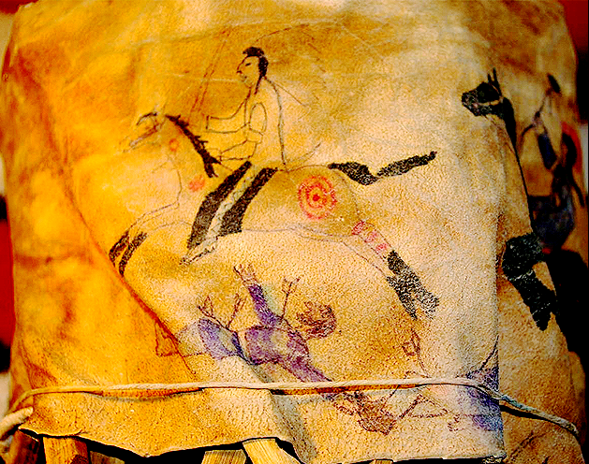

Fig. 3. Panel 1. Cheyenne Chieftain with a 20-eagle feather war bonnet, riding bareback on an Arabian with four black “socks,” painted with distinctive red ochre and grease markings: a War Shield Sun symbol on its neck, a bison hoof print on its withers, a target symbol on its left haunch and three stripes on its left rear leg. The chieftain is holding a U.S. Army Cavalry sword that he obviously procured from the U.S. Army Cavalry officer dispatched below.

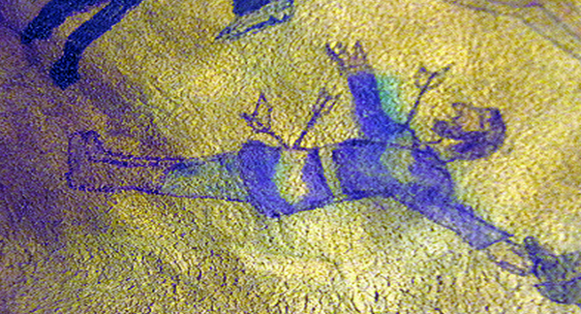

Fig. 5 A fully-bearded and long-haired U.S. Army Cavalry officer with a thigh-length coat and knee-length boots, struck with three arrows, one in his right sword-slashing arm and two in his lower gut. His eyes are drawn as slits indicating he is dead. The white and green areas were probably once blood-red but have been faded by sunlight (ultraviolet radiation). It appears that a Cheyenne body piece is attached to his neck suggesting that he either scalped or sexually mutilated one of the villagers that were in the camp.

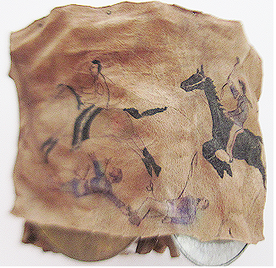

Fig. 6. Panels 1 and 2.

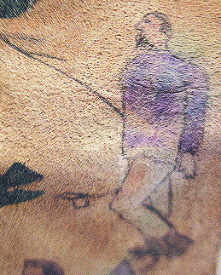

Figs. 7-8. Panel 2. Detail. This was a Major of the U.S. Army Cavalry, with full dress coat, trousers. His hair is neatly cut unlike the younger officer next to him. An arrow in his thigh would have incapacitated him. His distinctive officer’s uniform probably attracted the attention of a Cheyenne lancer who challenged him up close as possible and then thrust a lance into his abdomen, a sure but slow and painful death, which would take 15-30 minutes to kill a victim. His eyes are open suggesting that he was still alive when this drawing was made. Something red was placed in his mouth that can be seen above his distinctive goatee beard. This may have been one of his body parts.

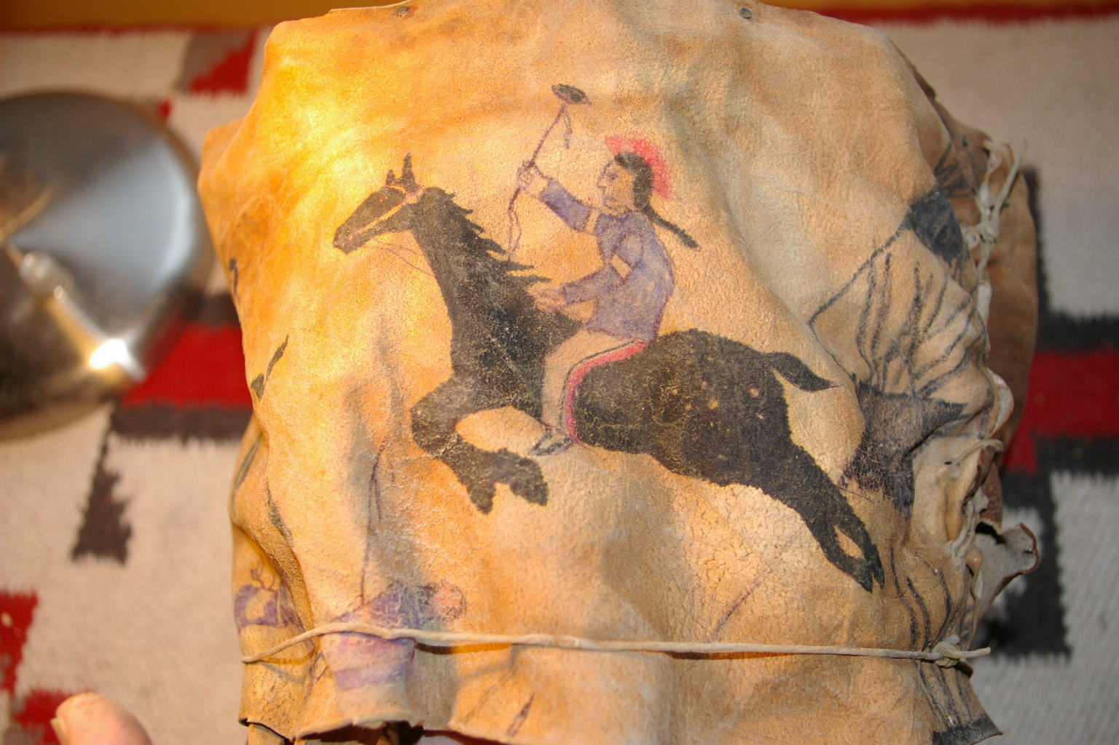

Fig. 9. Panel 2.



Fig. 10. Panel 2. The second Cheyenne bareback rider has a red-ochre-colored roach and wears a U.S. Army Cavalry jacket which he obviously took from a soldier he had killed. He also wears rawhide pants with a red stripe signifying war ironically mimicking the Cavalry’s blue trousers that signify peace. He wields a stone axe with two scalps of human hair (he had counted coup from a soldier) one at the base of the axe head and one at the base of the handle. The black snowflake appaloosa he is riding has 8 spots on its hind quarter, a particularly valued type of horse for warfare on the plains, since it was fearless and fast.

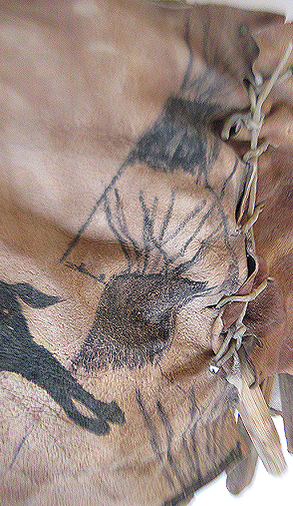

Fig. 11. Panel 3. The Sand Creek Village tipis that the U.S. Army Cavalry under Colonel John Chivington. Raided. The tipi on the bottom has been cut away to make the rawhide strip fit the drum. Note there are no human figures in this panel because the U.S. Army cavalry under Colonel John Chivington killed all the old men, women, children, babies and fetuses numbering over 500 total and not the 150 the NPS contends since there were 100 tipis with five souls at least to a tipi.

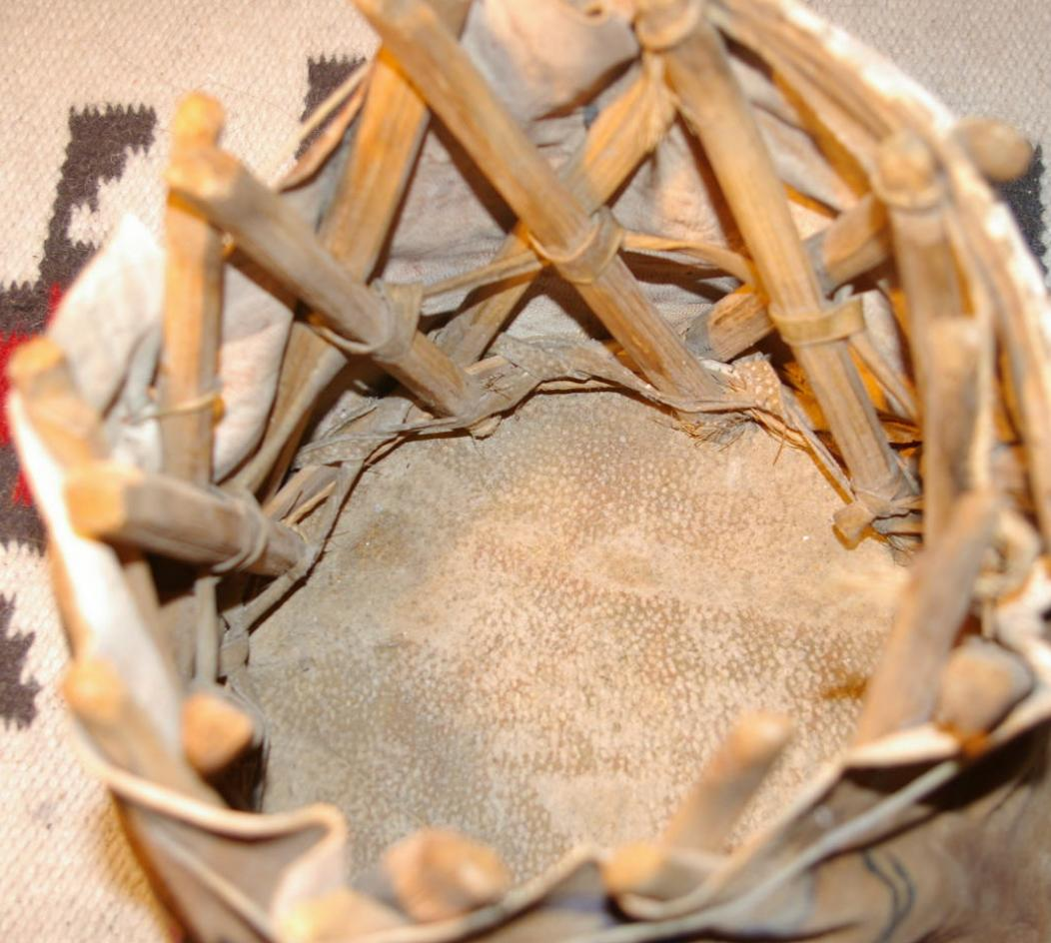

Figs. 12-13. View of the underside of the Sand Creek Massacre Drum with a cane frame lashed with bison sinew supporting a bison rawhide exterior.

Case no.: 12

Accession Number: A 2623

Formal Label:

**Display Description:**

This is a Cheyenne War Drum memorializing the Sand Creek Massacre and its aftermath. It is composed of three parts. The first part is a War Shield similar to but smaller than a full-sized battle shield made from a bison-hide parfleche. A *nemevota* or Thunderbird is outlined in red, the color of war which is connected to a continuous red circle outlined in green symbolizing the circular *vestoz* or Sand Creek tipi village that is now outlined in green, the color of life, protection from death, deriving its power from *nemevota*.

Secondly, a River Cane (*Arundinaria gigantean*) frame was bound with bison sinew and attached to the War Shield.

Thirdly a bison rawhide strip enclosed the River Cane frame detailing the story of the revenge of the Sand Creek Massacre in three panels. Panel 1 is a warrior chieftain with a war bonnet of 20 eagle feathers and his victim, a youthful U.S. Army Cavalry Office beneath his palomino with distinctive black “socks”. Panel 2 is a warrior with a red roach bareback riding a black snowflake appaloosa wielding a bow and arrow. Panel 3 is a view of three Sand Creek tipis without any visible inhabitants since they had all been killed.

The Sand Creek Massacre on November 29, 1864, was perpetrated on a peaceful village of over 500 Cheyenne and Arapaho old men, women, children babies and unborn fetuses in southeastern Colorado Territory by 675 Colorado U.S. Army Cavalry Volunteers under the command of U.S. Army Colonel John Chivington. The U.S. Army Cavalry murdered and mutilated the entire encampment.

When the returning men of the village found their loved ones murdered, scalped and sexually mutilated, probably the War Shield was hastily manufactured and painted in the style of “Parfleche,” a word that French fur traders had coined from “parer” “to defend,” and from “fleche,” “arrow,” indicating that the parfleche hide was tough enough to be used as a shield to deflect an arrow and, hopefully, bullets. Parfleche is made by removing hair from a bison hide by soaking it in ashes, which contains caustic potassium carbonate that prepares the hide for easier scraping with sharpened stones or iron scrapers. Then the hide is stretched and staked to the ground or a wooden frame with the hair side down. The process is repeated until the hide was sufficiently toughened. Possibly, this parfleche was taken as a ceremonial symbol of invoking protection from *nemevota* as Sand Creek warriors set off on their quest for the murderers of their villagers.

After the initial raid on the retreating U. S. Army Cavalry, the drum was constructed. The parfleche Thunderbird was attached to the River Cane frame with bison sinew. Then the brain-tanned bison rawhide strip encircling the drum was penciled and painted and attached to the frame with bison sinew. On the first two “panels” it records two Cheyenne warriors on horseback who counted coup (or dispatched) two U.S. Army Cavalry Officers. The strip of rawhide was hastily planned so that on “Panel Three” one of the images of the Sand Creek Village tipis was partially eliminated. This part of the drum was probably done making ready for further engagements with the fleeing U.S. Army Cavalry. The style was drawn with pencils that had been confiscated in a raid in what would become the hallmark of “Ledger Drawings.”

A “Ledger Drawing” marks a transition in First Nation Plains artistic expression between 1860 and 1900, when, depleted of bison and their original homelands, First Nations peoples were first amalgamated on Indian reservations by the U.S. Government to dilute and thereby destroy their traditions, notably the Sundance which was outlawed by the U.S. and Canadian Governments in the 1890’s.

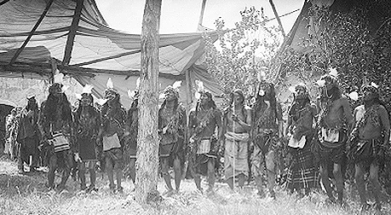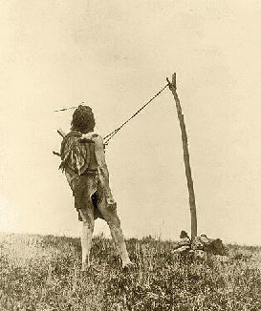

Fig. 14. Cheyenne Sundance c 1909, with 10 participants blowing eagle bone whistles preparatory to their chest muscles being attached to the lines of the Sundance world tree under the guidance of an elder (holding a staff, right of center), The entire ceremony lasting four days is taking place within a Sundance “tent”. United States [Library of Congress](https://commons.wikimedia.org/wiki/Library_of_Congress), [Prints and Photographs division](https://www.loc.gov/rr/print/) under the digital ID [pan.6a08724](http://hdl.loc.gov/loc.pnp/pan.6a08724)

Fig. 15. **For Strength and Visions**. Edward S. Curtis photographed this Crow (Apsaroke) man, leaning back slightly, with strips of leather attached to two bone skewers that pierced under his chest muscles and were tethered to a pole secured by rocks, a ritual atonement for transgressing the commands of the Great Spirit that had resulted in losing their way of life on the Great Plains. The atonement lasted at least four days or until a dancer experienced a vision.*– Courtesy Library of Congress –After https://s22658.pcdn.co/wp-content/uploads/2014/12/apsaroke-tethered-to-pole.jpg*

This drum may have been used in a Sundance that involved the use of a traditional drum, a sacred fire, praying with a ceremonial pipe, fasting from food and water before participating in the dance, and a ceremonial attachment of bone skewers into the chest muscles of young males who are suspended from an arbor-like frame against which they are centrifugally suspended in a Jesus-like crucifixion making physical penitence to the Great Spirit for the whole group whose infractions against the Great Spirit had resulted in their losing their way of life and their being unjustly treated by the U.S. Government. As a final act of the U. S. Government many of these amalgamated groups were then shipped hundreds of miles away to unfamiliar destinations, where they were incarcerated, notably to Fort Marion, Florida.

Herds of Great Plains game animals such as bison and antelope had been decimated by the Union and Confederate Armies during the Civil War, and those bison that were left had their annual migration routes to Canada cut by the Union Pacific Railroad in 1869, hich offered urban rich shooters the weekend of a lifetime to kill as many bison as they could within a 48 hour period riding west on their “shotgun cars”. The mass production of hundreds of barbed wire types in the 1870’s and 1880’s was the final death knell for all migratory land species. The bison that was the essential source for the rawhide on this drum vanished in a period of fifteen years. The alternative artistic medium was, ironically but not tragically, ledger paper that was used to account for U.S. Government rations by “Indian agents,” and it became the only substitute of choice for the devastated bison. First Nations’ artists were experimentalists, and they acquired new, unforeseen political power when they expertly adapted to the relatively smaller sizes of ledger paper and the new coloring pencils made available through Government Agents. These two seemingly insignificant innovations ironically transformed recording of their experiences of forced incarceration and endured physical atrocities with powerful details unachievable before, and using this new medium they reached nation-wide audiences who became better aware of their civil rights circumstances.

Date or Time Horizon: December 1-2, 1864

Geographical Area: Sand Creek, Kiowa County, Colorado

**Map:**



**Figs. 15-16. https://www.nps.gov/sand/planyourvisit/images/Revised-Driving-Directions-2018_**



Fig. 17. Location of the Sand Creek Village located by the U.S. Government in an area of inarable land after <https://www.nps.gov/common/uploads/grid_builder/imr/crop16_9>

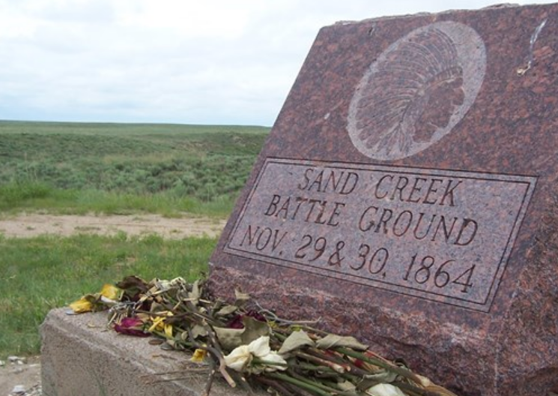

**The U.S. National Park Service Sand Creek memorial which is wrong on two accounts. First, it emblazons the site as a “Battle Ground” which is incorrect: it is a Massacre Site. The villagers were gunned down without a fight. Secondly, the supposed Cheyenne chieftain has a war bonnet with no eagle feathers with black bases and white uppers. These feathers whatever bird they belong to are also too numerous, about thirty. However, there were no Cheyenne chieftains present when the U.S. Army Cavalry opened fire on the villagers. After http://img.groundspeak.com/waymarking/large/53e0f463-bd3f-41c7-a3fc-5aa11152c018.JPG**

**GPS coordinates:** N 38° 32.973 W 102° 30.689

Cultural Affiliation: Southern Cheyenne

Media: The tympanum is a Cheyenne War Drum bison parfleche that has been scraped free of hair and then stretched on a frame and dried. The drum’s housing is a bison rawhide strip that has been bison-brain tanned and then painted similar to a ledger drawing with the account of the massacre. The frame is cane from Sand Creek. The colors are black, vermilion and blue

Dimensions: Dia. 10.5, H 8.5 in

Weight: 1 lb 12 5/8 ox; 812 gm

Condition: original

Provenance: Oklahoma estate sale

**Discussion:**

The Sand Creek Massacre of about 150 Cheyenne occurred before dawn on November 29, 1864, in southeastern Colorado Territory, while most of the men of the village were away hunting dispersed bison at the “command” of . More than 700 soldiers, mostly volunteer Colorado state militia, and two artillery 6cannon attacked a Cheyenne encampment on Sand Creek, killing and scalping old men, killing women and mutilating their reproductive organs, and killing young children and babies.

Leading the attack was U. S. Army Colonel John M. Chivington, a former Methodist preacher known as the "Fighting Parson." Chivington had earlier stated his life’s mission was "to kill Indians." At Sand Creek, he ignored peace signals, an American flag and a white flag hanging from the lodge of Mo'ohtavetoo'o (“Black Kettle”), chief of the Southern Cheyenne. Black Kettle, among those who survived, died four years later in another attack, by troops under Lt. Col. George A. Custer at the Washita River in Oklahoma.

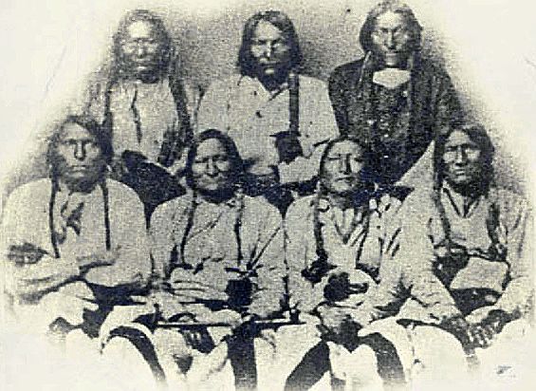

A delegation of Cheyenne, Kiowa, and Arapaho chiefs in Denver, Colorado, on September 28, 1864, three months before the massacre. *Mo'ohtavetoo'o* (“Black Kettle,” c 1803 – November 27, 1868) is in the front row, second from the left. His calumet or “peace pipe” has a spiral stem indicating the smoke spiral that ascends to the Great Spirit who seals the agreement only when it is joined to a red Pipestone pipe bowl. Stems and Pipestone bowls are never joined unless there is an accompanying significant event like a peace treaty in which the pipe has been smoked by all parties honoring heir common intent as the smoke rises to the Great Spirit. After <https://upload.wikimedia.org/wikipedia/commons/7/76/Portrait_of_Black_Kettle_or_Moke-Tao-To%3F_and_Delegation_Of_Cheyenne_and_Arapaho_Chiefs_28_SEP_1864.jpg>

THIRTY-EIGHTH CONGRESS, SECOND SESSION.

CONGRESS OF THE UNITED STATES.

In the House of Representatives, January 10, 1865.

On motion of Mr. Orth,

Resolved, That the Committee on the Conduct of the War be required to inquire into and

report all the facts connected with the late attack of the third regiment of Colorado volunteers, under Colonel Chivington, on a village of the Cheyenne tribe of Indians, near

Fort Lyon.

Attest:, Clerk.

The Joint Committee on the Conduct of the War submit the following report:

In the summer of 1864 Governor Evans, of Colorado Territory,

as acting superintendent of Indian affairs, sent notice to the various

bands and tribes of Indians within his jurisdiction that such as de-

sired to be considered friendly to the whites should at once repair to

the nearest military post in order to be protected from the soldiers

who were to take the field against the hostile Indians.

About the close of the summer, some Cheyenne Indians, in the

neighborhood of the Smoke Hills, sent word to Major Wynkoop, the

commandant of the post of Fort Lyon, that they had in their pos-

session, and were willing to deliver up, some white captives they had

purchased of other Indians. Major Wynkoop, with a force of over

100 men, visited those Indians and received the white captives. On

his return he was accompanied by a number of its chiefs and leading

men of the Indians, whom he had invited to visit Denver for the

purpose of conferring with the authorities there in regard to keeping

peace. Among them were Black Kettle and White Antelope of the

Cheyennes, and some chiefs of the Arapahoes. The council was

held, and these chiefs stated that they were friendly to the whites,

and always had been, and that they desired peace. Governor Evans

and Colonel Chivington, the commander of that military district, ad-

vised them to repair to Fort Lyon and submit to whatever terms the

military commander there should impose. This was done by the

Indians, who were treated somewhat as prisoners of war, receiving

rations, and being obliged to remain within certain bounds.

Digitized by VjOOQIC

II MASSACRE OF CHEYENNE INDIANS.

All the testimony goes to show that the Indians, under the immediate control of Black Kettle and White Antelope of the Cheyennes, and Left Hand of the Arapahoes, were and had been friendly to the whites, and had not been guilty of any acts of hostility or depredation. The Indian agents, the Indian interpreter and others examined by your committee, all testify to the good character of those Indians.

Even Governor Evans and Major Anthony, though evidently willing

to convey to your committee a false impression of the character of

those Indians, were forced, in spite of their prevarication, to admit

that they knew of nothing they had done which rendered them de-

serving of punishment.

A northern band of the Cheyennes, known as the Dog Soldiers,

had been guilty of acts of hostility; but all the testimony goes to

prove that they had no connexion with Black Kettle's band, but acted

in despite of his authority and influence. Black Kettle and his band

denied all connexion with or responsibility for the Dog Soldiers, and

Left Hand and his band of Arapahoes were equally friendly.

These Indians, at the suggestion of Governor Evans and Colonel Chivington, repaired to Fort Lyon and placed themselves under the protection of Major Wynkoop. They were led to believe that they were regarded in the light of friendly Indians, and would be treated

as such so long as they conducted themselves quietly. The treatment extended to those Indians by Major Wynkoop does not seem to have satisfied those in authority there [i.e., Governor Evans and Colonel Chivington], and for some cause, which does not appear, he was removed,

and Major Scott J. Anthony was assigned to the command of Fort Lyon; but even Major Anthony seems to have found it difficult at first to pursue any different course towards the Indians he found there. They were entirely within the power of the military. Major Anthony having demanded their arms, which they surrendered to him, they conducted

themselves quietly, avid in every way manifested a disposition to remain at peace with the whites. For a time even he continued issuing rations to them as Major Wynkoop had done;

but it was determined by Major Anthony (whether upon his own motion or at the suggestion of others [i.e., Governor Evans and Colonel Chivington] does not appear) to pursue a different course towards these friendly Indians. They were called together and told that rations could no longer be issued to them, and they had better go where they could obtain subsistence by hunting. At the suggestion of Major Anthony (and from one in his position a suggestion was equivalent to a command) these Indians went to a place on Sand creek, about thirty-five miles from Fort Lyon, and there established their camp, their arms being restored to them. He told them that he then had no authority to make peace with them; but in case he received such authority he would inform them of it. In his testimony he says:

I told them they might go back on Sand creek, or between there

and the headwaters of the Smoky Hill, and remain there until I

received instructions from the department headquarters, from General

Curtis: and that in case I did receive any authority to make peace

with them I would go right over and let them know it. I did not state,

to them that I would give them notice in case we intended to attack them.

They went away with that understanding, that in case I

received instructions from department headquarters I was to let them

know it."

Digitized by VjOOQIC

III. MASSACRE OF CHEYENNE INDIANS.

And in order, as it were, to render these Indians less apprehensive of any danger, One Eye, a Cheyenne chief, was allowed to remain with them to obtain information for the use of the military authorities. He was employed at $125 a month, and several times brought to Major Anthony, at Fort Lyon, information of proposed movements of other and hostile bands. Jack Smith, a half-breed son of John S. Smith, an Indian interpreter, employed by the government, was also there for the same purpose. A United States soldier was

allowed to remain there, and two days before the massacre Mr. Smith, the interpreter, was permitted to go there with goods to trade with the Indians.

Everything seems to have been done to remove from the minds of these Indians any fear of approaching danger ; and when Colonel Chivington commenced his movement he took all the precautions in his power to prevent these Indians learning of his approach. For some days all travel on that route was forcibly stopped by him, not even the mail being allowed to pass. On the morning of the 28th of November he appeared at Fort Lyon with

over 700 mounted men and two pieces of [6 pound] artillery. One of his first acts was to throw a guard around the post to prevent any one leaving it. At this place Major Anthony joined him with 125 men and two

pieces of artillery.

IV MASSACRE OF CHEYENNE INDIANS.

On the night of the 28th the entire party started from Fort Lyon, and, by a forced march, arrived at the Indian camp, on Sand creek, shortly after daybreak. This Indian camp consisted of about 100 lodges of Cheyennes, under Black Kettle, and from 8 to 10 lodges of Arapahoes under Left Hand. It is estimated that each lodge contained five or more persons, and that more than one-half were women and children.

Upon observing the approach of the soldiers, Black-Kettle, the head chief, ran up to the top of his lodge an American flag, which had been presented to him some years before by Commissioner Greenwood, with a small white flag under it, as he had been advised to do in case he met with any troops on the prairies. Mr. Smith, the interpreter, supposing they might be strange troops, unaware of the character of the Indians encamped there, advanced from his lodge to meet them, but was fired upon, and returned to his. lodge.

And then the scene of murder and barbarity began as to men, women, and children ware indiscriminately slaughtered. In a few minutes all the Indians were flying over the plain in terror and confusion. A few who endeavored to hide themselves under the bank of the creek were surrounded and shot down in cold blood, offering but feeble resistance. From the sucking babe to the old warrior, all who were overtaken were deliberately murdered. Not content with killing women and children, who were incapable of offering any resistance, the soldiers indulged in acts of barbarity of the most revolting character; such, it is to be hoped, as never before disgraced the acts of men claiming to be civilized. No attempt was made by the officers to restrain the savage cruelty of the men under their command, but they stood by and witnessed these acts without one word of reproof, if they did not incite their commission. For more than two hours the work of murder and barbarity was continued, until more than one hundred dead bodies [i.e., really c 500], three-fourths of them of women and children, lay on the plain as evidences of the fiendish malignity and cruelty of the officers who had so sedulously and carefully plotted the massacre, and of the soldiers who had so faithfully acted out the spirit of their officers.

It is difficult to believe that beings in the form of men, and disgracing the uniform of United States soldiers and officers, could commit or countenance the commission of such acts of cruelty and barbarity as are detailed in the testimony, but which your committee will not specify in their report.

It is true that there seems to have existed among the people inhabiting that region of country a hostile feeling

towards the Indians. Some of the Indians had committed acts of hostility towards the whites; but no effort seems to have been made by the authorities there to prevent these hostilities, other than by the commission of even worse acts. The hatred of the whites to the Indians would seem to have been inflamed and excited to the utmost; the bodies of persons killed at a great distance as to whether by Indians or not, is not certain as to who were brought to the capital of the Territory and exposed to the public gaze for the purpose of inflaming still more

the already excited feeling of the people.

Their cupidity was appealed to, for the governor in a proclamation calls upon all,

“either individually or in such parties as they may organize/ to kill and

destroy as enemies of the country, wherever they may be found, all

such hostile Indians," authorizing them to "hold to their own private

use and benefit all the property of said hostile Indians that they

may capture."

What Indians he would ever term friendly it is impossible to tell. His testimony before your committee was characterized by such prevarication and shuffling as has been shown by no witness they have examined during the four years they have been engaged in their investigations; and for the evident purpose of avoiding the admission that he was fully aware that the Indians massacred so brutally at Sand creek, were then, and had been, actuated by the most friendly feelings towards the whites, and had done all in their power to restrain those less friendly disposed.

V. MASSACRE OF CHEYENNE INDIANS.

The testimony of Major Anthony, who succeeded [as] an officer disposed to treat these Indians with justice and humanity, is sufficient of itself to show how unprovoked and unwarranted was this massacre.

He testifies that he found these Indians in the neighborhood of Fort Lyon when he assumed command of that post; that they professed their friendliness to the whites, and their willingness to do whatever he demanded of them; that they delivered their arms up to him; that they went to and encamped upon the place designated by him; that they gave him information from time to time of acts of hostility which were meditated by other and hostile bands, and in every way conducted themselves properly and peaceably, and yet he says it was fear and not principle which prevented his killing them while they were completely in his power.

And when Colonel Chivington appeared at Fort Lyon, on his mission of murder and barbarity, Major Anthony made haste to accompany him with men and artillery, although Colonel Chivington had no authority whatever over him.

As to Colonel Chivington, your committee can hardly find fitting terms to describe his conduct. Wearing the uniform of the United States, which should be the emblem of justice and humanity; holding the important position of commander of a military district, and therefore having the honor of the government to that extent in his keeping, he deliberately planned and executed, a foul and dastardly massacre which would have disgraced the veriest savage among those who were the victims of his cruelty. Having full knowledge of their friendly character, having himself been instrumental to some extent in placing them in their position of fancied security, he took advantage of their inapprehension and defenceless [sic] condition to gratify the worst passions that ever cursed the heart of man. It is thought by some that desire for political preferment prompted him to this cowardly act; that he supposed that by pandering to the inflamed passions of an excited population he could recommend himself to their regard and consideration. Others think it was to avoid the being sent where there was more of danger and hard service to be performed; that he was willing to get up a show of hostility on the part of the

Indians by committing himself acts which savages themselves would never premeditate. Whatever may have been his motive, it is to be hoped that the authority of this government will never again be disgraced by acts such as he and those acting with him have been guilty of committing.

**=============================================================================**

# Sand Creek Massacre names

A list of Cheyenne family heads present at the Sand Creek Massacre in 1864 was printed in the September 1982 issue of the *Northern Cheyenne Tribal News*. Names were given in English and Cheyenne. The original Cheyenne was apparently written by a government agent and is very difficult to decipher. Here is an attempt to figure out what the Cheyenne names were. There are many uncertainties:

White Hat

Bear Skin

Wounded Bear

Bear Feathers

Cross Necklace vo'otane ?

Two Lances Néše Xomoono ?

Black Wolf

White Antelope Vó'kaa'e Ohvó'komaestse

One Eye

Tall Bear

Black Kettle Mo'(k?)ôhtávetoo'o

Feather Head

Tall Wolf

Heap of Crows

Spotted Corn

Man Standing in the Water

Big Head

Red Arm

Sitting Bear

The Kiowa

Big Shell

Wolf Mule

The Man Heéháme/Hetane?

Full Bull O'otóm ?

The Stick Kâhamaxe

Wolf That Hears Hó'neohnéstoohe (Howling Wolf?)

Pointed Tomahawk Eškôseto ?

One Leg

Bull That Hears ? néstoohe

Seven Bulls ? nésohto ?

Big Owl Méstaa'a ?

Bear Shield

Black Antelope Vó'kaa'e Ohmo'(k?)ôhtávaestse

Bull Neck

Snake še'šenovôtse

Lame Man Nóhné'áhe ?

Wolf Horn vevêstse ?

Bear Tongue Náhkôhe-vétanove ?

Wolf Tongue Ho'néhe-vétanove

Leg Calf

Wolf That Speaks

Little Bear Náhkôxháahketa ?

Bird That Flies

Spotted Horns ? véveto ?

Found Sun Eše'ôhmé'éhne ?

Empty Belly

Red Sheath

The Squirrel

The Road

Bull Pup

The Man That Peeps Over the Hill

Heap of Cows

Little Wolf Hó'neoxháahketa ?

Shawnee Savano

Wolf Road

Scabby Man Oevemana

Arapahoe Hetanevo'e

Bushy Hair

Wolf Grey

Standing Polecat

Black Horse

Small Belly

Loser in the Race

Four Bears

Old Bear Náhkohe ??

Blue Crane

Polecat

Point of Rocks

White Calf (related to Véstaa'e ?)

Black Kettles Brother

Whirl Wind

Spirit Walking

Walking Crane (related to Véstaso ?)

Forked Stick

Cross

Iron Ma'aeta

Big Child

Vermillion Ma'etomo (e?)

One that Kills

Big Louse

Man on Top of the Hill

Following Turtle Ma'eno ??

White Beaver

Wooden Leg Kâhamâxêhahtáhe ?

Big Rib ? he'pe

Sand Hill

Mad Bull

Bird Tail Voto ?

Shoving Bear

Stuffed Gut Hestâhtotse ?

Little Beaver Hóma'e

Yellow Wolf

Red Bird Ma'eve'êse

White Man Vé'ho'e

Male Cross

Yellow Woman Heóva'e ??

Male Cherry Hetanémene ??

Bear Above He'ama Náhkohe ?

Smooth Face ?? énéhe

Bear Tent Náhkohe ??

Blacktail Eagle

Coffee Kape ? (English borrowing)

Cut Nose

Hog

Wounded Bear Náhkohe ??

Found Dog Hotamomé'éhne ?

Foot Track

Bobtail Wolf

The Elk Mo'ehe ?

Spanish Woman

Blue Horse Otá'tavahe ?

**References:**

Petter, R.C., 1915. *English-Cheyenne Dictionary*. Kettle Falls, WA.

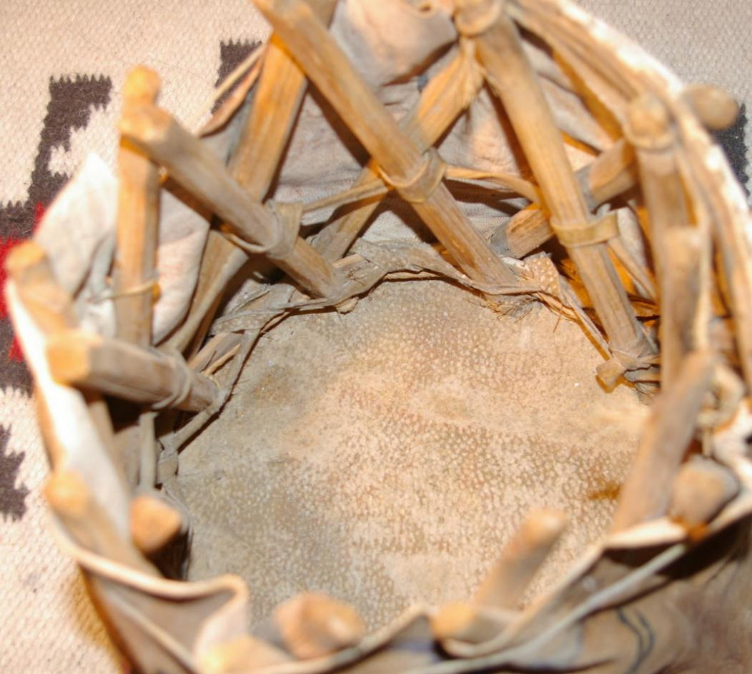

|  |  |
| --- | --- |
| ORDER DATEApr 17, 2016 | ORDER TOTAL  US $150.00  + US $15.00  shipping  **Order ** Indian Stool,Ledger Paintings,,Vintage,Old,Antique\*\*** [Leave feedback - ORDER DATE Apr 17, 2016](http://feedback.ebay.com/ws/eBayISAPI.dll?LeaveFeedbackShow&useridto=granitestatetrade&transactID=0&item=131779500370&_trksid=p2057872.m2749.l2665)[View order details](http://payments.ebay.com/ws/eBayISAPI.dll?ViewPaymentStatus&transId=0&itemid=131779500370&_trksid=p2057872.m2749.l2673) - ORDER DATE Apr 17, 2016  [More actions - ORDER DATE Apr 17, 2016](http://www.ebay.com/myb/PurchaseHistory) |

1 item sold by [granitestatetrade](http://www.ebay.com/usr/granitestatetrade?_trksid=p2057872.m2749.l2754)

|  |  |  |  |  |  |
| --- | --- | --- | --- | --- | --- |
| [** Indian Stool,Ledger Paintings,,Vintage,Old,Antique**](http://www.ebay.com/itm/131779500370?_trksid=p2057872.m2749.l2649&ssPageName=STRK%3AMEBIDX%3AIT)  ( 131779500370 )  Delivered on Tue, Apr 19  Tracking number: [**Tracking number**9505514791116109006536](javascript:;)  [Add note](javascript:;) | | | | ITEM PRICE:  US $150.00 |  |
|  | ORDER DATEApr 10, 2016 | ORDER TOTAL  US $1,550.00  + US $35.00  shipping  **Order Ledger Drawing Native American Indian Very Nice,VINTAGE Ledger Drawing Native American Indian Estate Find,Ledger Drawing Native American Indian Killing Soldiers Estate Sale Find,Ledger Drawing Native American Indian Fighting Soldiers Estate Sale Find,Ledger Drawing Native American Indian Battling Soldiers Estate Sale Find** [View order details - ORDER DATE Apr 10, 2016](http://payments.ebay.com/ws/eBayISAPI.dll?ViewPaymentStatus&transId=1304370973013&itemid=231909000466&_trksid=p2057872.m2749.l2673)[Contact seller](http://contact.ebay.com/ws/eBayISAPI.dll?ShowSellerFAQ&requested=onepeople43&iid=231909000466&redirect=0&_trksid=p2057872.m2749.l2652) - ORDER DATE Apr 10, 2016  [More actions - ORDER DATE Apr 10, 2016](http://www.ebay.com/myb/PurchaseHistory) |  | | |

5 items sold by [onepeople43](http://www.ebay.com/usr/onepeople43?_trksid=p2057872.m2749.l2754)

|  |  |  |
| --- | --- | --- |
| [Ledger Drawing Native American Indian Very Nice](http://www.ebay.com/itm/231909000466?_trksid=p2057872.m2749.l2649&ssPageName=STRK%3AMEBIDX%3AIT)  ( 231909000466 )  Estimated delivery Thu, Apr 14 - Mon, Apr 18  [Add note](javascript:;) | ITEM PRICE:  US $250.00 | **Item Ledger Drawing Native American Indian Very Nice Orders 231909000466-0-1304370973013**[Leave feedback](http://feedback.ebay.com/ws/eBayISAPI.dll?LeaveFeedbackShow&useridto=onepeople43&transactID=1304370973013&item=231909000466&_trksid=p2057872.m2749.l2665)[Return this item](http://postorder.ebay.com/Return/ReturnViewSelectedItem?transactionId=1304370973013&itemId=231909000466&_trksid=p2057872.m2749.l3185)  [More actions](http://www.ebay.com/myb/PurchaseHistory) |

|  |  |  |
| --- | --- | --- |
| [VINTAGE Ledger Drawing Native American Indian Estate Find](http://www.ebay.com/itm/371596778648?_trksid=p2057872.m2749.l2649&ssPageName=STRK%3AMEBIDX%3AIT)  ( 371596778648 )  Estimated delivery Thu, Apr 14 - Mon, Apr 18  [Add note](javascript:;) | ITEM PRICE:  US $250.00 | **Item VINTAGE Ledger Drawing Native American Indian Estate Find Orders 371596778648-0-823333870024**[Leave feedback](http://feedback.ebay.com/ws/eBayISAPI.dll?LeaveFeedbackShow&useridto=onepeople43&transactID=823333870024&item=371596778648&_trksid=p2057872.m2749.l2665)[Return this item](http://postorder.ebay.com/Return/ReturnViewSelectedItem?transactionId=823333870024&itemId=371596778648&_trksid=p2057872.m2749.l3185)  [More actions](http://www.ebay.com/myb/PurchaseHistory) |

|  |  |  |
| --- | --- | --- |
| [Ledger Drawing Native American Indian Killing Soldiers Estate Sale Find](http://www.ebay.com/itm/371596785063?_trksid=p2057872.m2749.l2649&ssPageName=STRK%3AMEBIDX%3AIT)  ( 371596785063 )  Estimated delivery Thu, Apr 14 - Mon, Apr 18  [Add note](javascript:;) | ITEM PRICE:  US $350.00 | **Item Ledger Drawing Native American Indian Killing Soldiers Estate Sale Find Orders 371596785063-0-823333869024**[Leave feedback](http://feedback.ebay.com/ws/eBayISAPI.dll?LeaveFeedbackShow&useridto=onepeople43&transactID=823333869024&item=371596785063&_trksid=p2057872.m2749.l2665)[Return this item](http://postorder.ebay.com/Return/ReturnViewSelectedItem?transactionId=823333869024&itemId=371596785063&_trksid=p2057872.m2749.l3185)  [More actions](http://www.ebay.com/myb/PurchaseHistory) |

|  |  |  |
| --- | --- | --- |
| [Ledger Drawing Native American Indian Fighting Soldiers Estate Sale Find](http://www.ebay.com/itm/371596787094?_trksid=p2057872.m2749.l2649&ssPageName=STRK%3AMEBIDX%3AIT)  ( 371596787094 )  Estimated delivery Thu, Apr 14 - Mon, Apr 18  [Add note](javascript:;) | ITEM PRICE:  US $350.00 | **Item Ledger Drawing Native American Indian Fighting Soldiers Estate Sale Find Orders 371596787094-0-823333868024**[Leave feedback](http://feedback.ebay.com/ws/eBayISAPI.dll?LeaveFeedbackShow&useridto=onepeople43&transactID=823333868024&item=371596787094&_trksid=p2057872.m2749.l2665)[Return this item](http://postorder.ebay.com/Return/ReturnViewSelectedItem?transactionId=823333868024&itemId=371596787094&_trksid=p2057872.m2749.l3185)  [More actions](http://www.ebay.com/myb/PurchaseHistory) |

|  |  |  |
| --- | --- | --- |
| [Ledger Drawing Native American Indian Battling Soldiers Estate Sale Find](http://www.ebay.com/itm/371596788954?_trksid=p2057872.m2749.l2649&ssPageName=STRK%3AMEBIDX%3AIT)  ( 371596788954 )  Estimated delivery Thu, Apr 14 - Mon, Apr 18  [Add note](javascript:;) | ITEM PRICE:  US $350.00 | **Item Ledger Drawing Native American Indian Battling Soldiers Estate Sale Find Orders 371596788954-0-823333871024**[Leave feedback](http://feedback.ebay.com/ws/eBayISAPI.dll?LeaveFeedbackShow&useridto=onepeople43&transactID=823333871024&item=371596788954&_trksid=p2057872.m2749.l2665)[Return this item](http://postorder.ebay.com/Return/ReturnViewSelectedItem?transactionId=823333871024&itemId=371596788954&_trksid=p2057872.m2749.l3185)  [Mo](http://www.ebay.com/myb/PurchaseHistory) |